1. Create a Blog Using Blogspot Customize the theme Design and post new Article with 500 words

Explore the Latest Trends with Our Trending Collections Blog! From fashion to tech, we curate the most current and captivating collections just for you. Stay in the know, discover what's hot, and get inspired. Don't miss a beat – follow us for your dose of trending delights

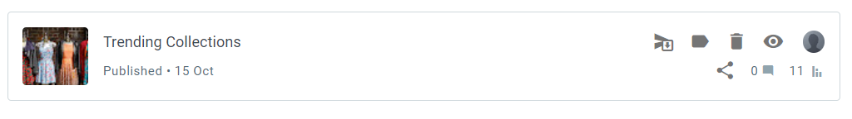

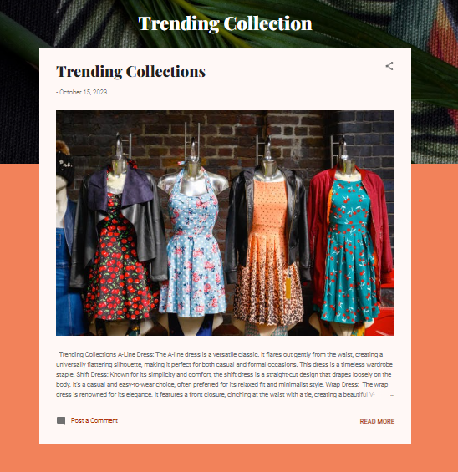

Trending Collections[:https://trendingstylecollection.blogspot.com/2023/10/treading-collections.html](https://trendingstylecollection.blogspot.com/2023/10/treading-collections.html)

1. Create a New Facebook Business Page and Post one Social media Poster for your Brand

Welcome to our Facebook Business Page! We're here to serve your needs with top-quality products/services in [Trending Collections]. Stay updated on our latest offerings, promotions, and news. Join us on a journey of excellence and satisfaction. Your success is our priority.

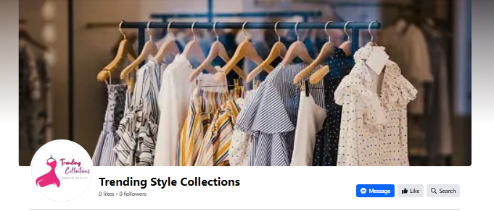

Explore the Latest Trends

Discover the hottest trends in fashion, technology, home decor, and more. Stay in the know with our curated collections, style tips, and innovative finds.

Be Inspired

Find the inspiration you need to keep up with what's hot and elevate your style and lifestyle.

Trending Collections Facebook Page:<https://www.facebook.com/profile.php?id=61552625003286>

1. Create and Design a social media advertisement poster using Canva

Looking for the latest fashion, tech gadgets, or lifestyle inspirations? Search no further! Join us to explore trending products and must-have items. From fashion-forward looks to innovative tech, we curate the finest collections just for you. Stay ahead of the trends – follow us today and never miss out on what's hot! #TrendingCollections

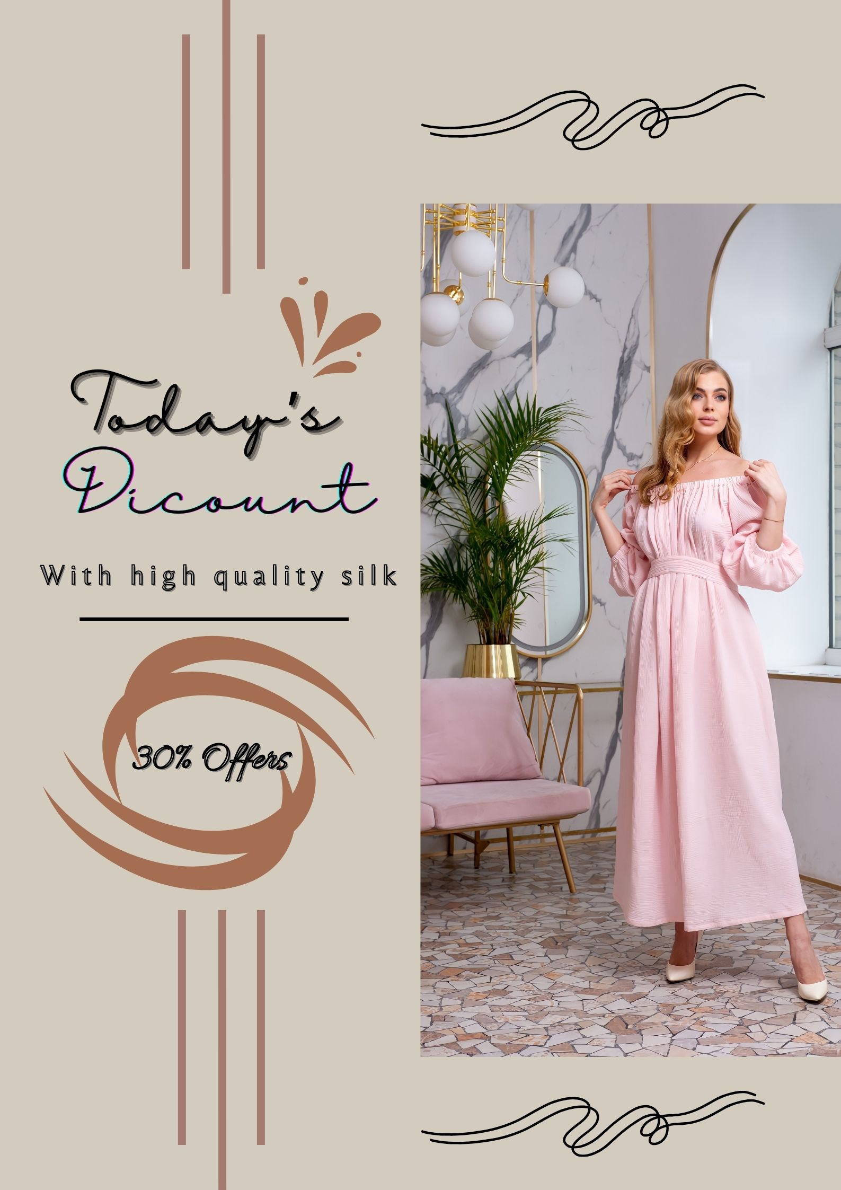

1. Create Email Newsletter Design Using Canva Tool

 Trending Collections! Discover the latest in fashion, tech, and lifestyle trends. From style inspiration to product recommendations, we've got you covered. Subscribe today for the freshest updates and stay ahead in the world of trends.

